What are Hazel Class learning in Term 1?

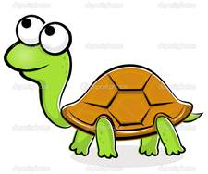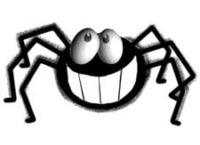

**English:**

Our own superhero story

Senses poem

Writing simple sentences with capital letters, finger spaces and full stops.

**Maths:**

Number –

Place Value (within 10)

Counting in 10s forwards.

**Science**

Naming parts of the body

Our five senses

Learn basic greetings using Makaton



**P.E.**

Yoga

Games

**Computing:**

E- Safety

Understanding different types of technology

**Art/D.T.**

Andy Warhol

Self Portraits

Superhero comic strips

**Music:**

“Hey you!” Hip Hop Music, exploring pulse, rhythm and pitch.

**What makes us super?**

**WOW days-**

Help Charlie the Superhero find his missing underpants!

Superhero day making capes, masks and potions.

School Nurse to visit.

**Geography:**

Our school and surrounding area

Local walk including a visit to some of our amenities.

**R.E./P.H.S.E.**

Jigsaw- “Being in my World”.

Harvest