|  |  |
| --- | --- |
| Senses | We have 5 basic senses. |
| Human | Is another word for a person. |
| City | We live in a city called Bristol. |
| Country | We live in a country called England! |

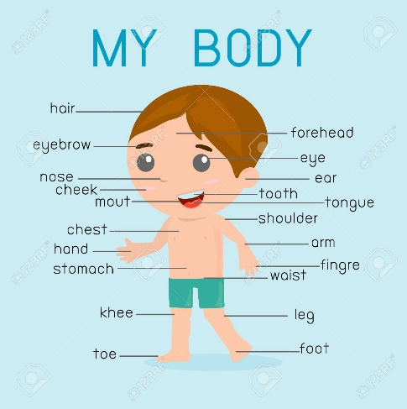

Do you know how many bones are in your body?

A baby is born with around 270 bones at birth but by adulthood this is around 206 as some bones fuse together!

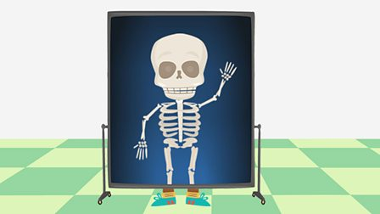

Term 1 – Superheroes

What makes us super?

